Name : Aishwarya B
Reg no :- 192321059
Course code :- CSA1616
Course Name:- Data Warehousing and Data Mining

Experiment-1

AIM:- To find intervals and corresponding frequencies.
Code:-
#age, frequency
age<-c(5,15,20,50,80,110)
frequency<-c(200,450,300,1500,700,44)
median(age) median(frequency) OUTPUT:-


Result:- It is executed successfully.

Experiment-2
Aim:- To find the data for analysis includes the attribute age. Code:-
#mean,median,mode,quatile
age<-c(13,15,16,16,19,20,20,21,22,22,25,25,25,25,30,33,33,35,35,35,35,36,40,45,46,52,70)
mean(age) median(age)
mode_age<-names(table(age))[table(age)==max(table(age))] mode_age
range(age) quantile(age,.25) quantile(age,.75) Output:-
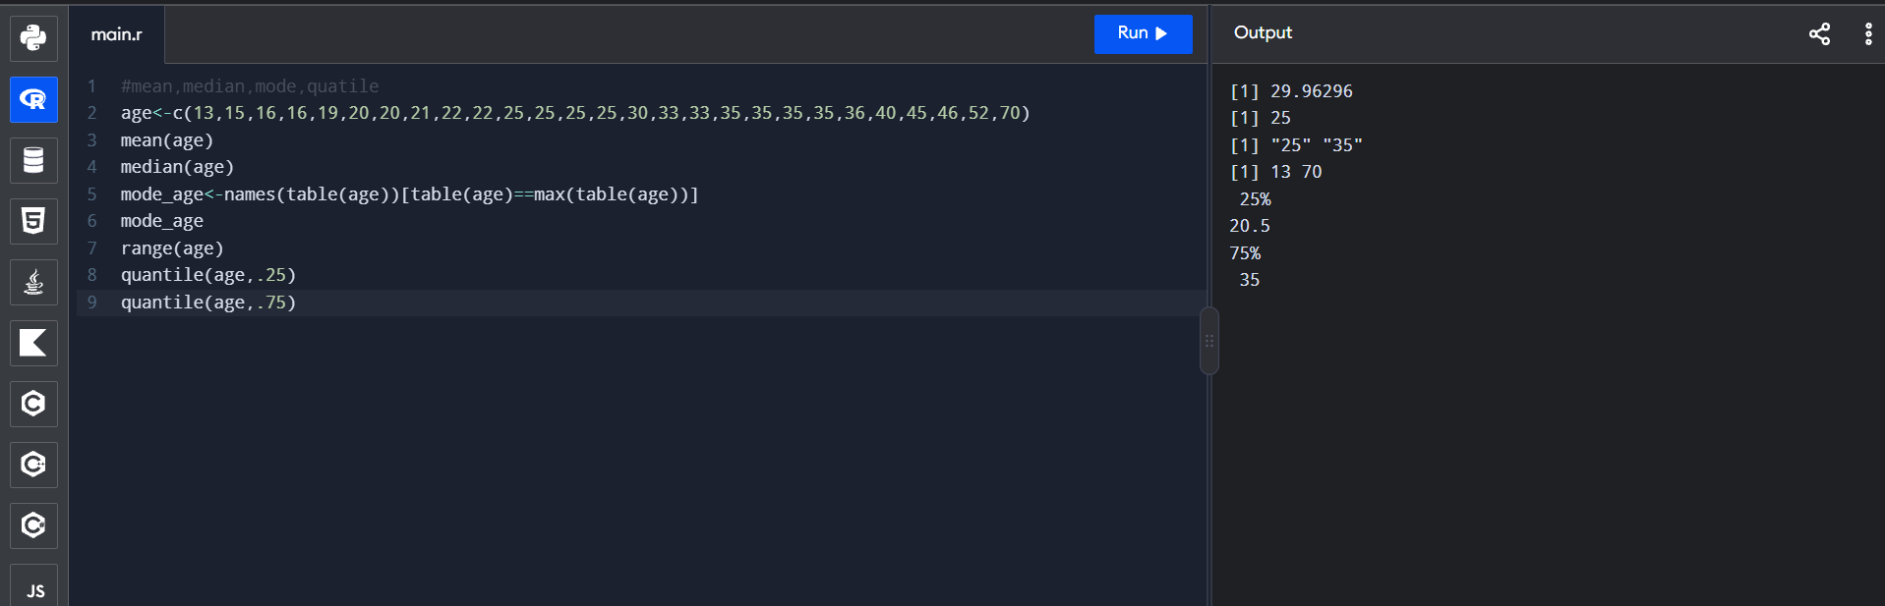
Result:- It is executed successfully.

Experiment-3
Aim:- To show Data Preprocessing IN Reduction and Transformation . Code:-
data <- c(11,13,13,15,15,16,19,20,20,20,21,21,22,23,24,30,40,45,45,45,71,72,73,75)
bins <- 5
bin_indices <- cut(data, bins)
mean_smooth <- tapply(data, bin_indices, mean) print(mean_smooth)
median_smooth <- tapply(data, bin_indices, median) median_smooth
min_max_smooth <- tapply(data, bin_indices, function(x) c(min(x), max(x))) print(min_max_smooth)
output:-
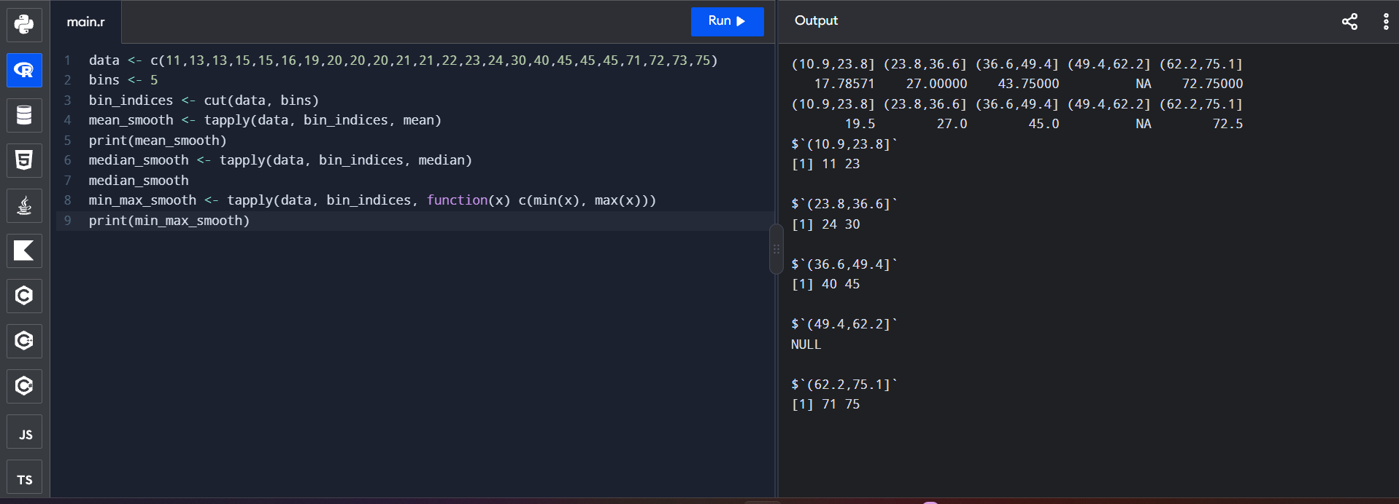
Result:- It is executed successfully.

